1. Print default values of static & instance variables for different data types.

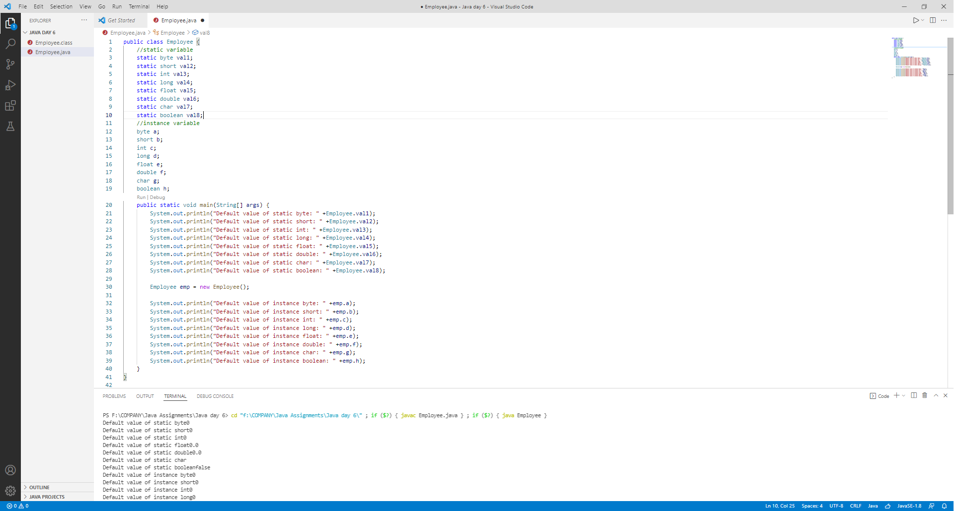

1. Build a class Employee which contains details about the employee and compile and run its instance.

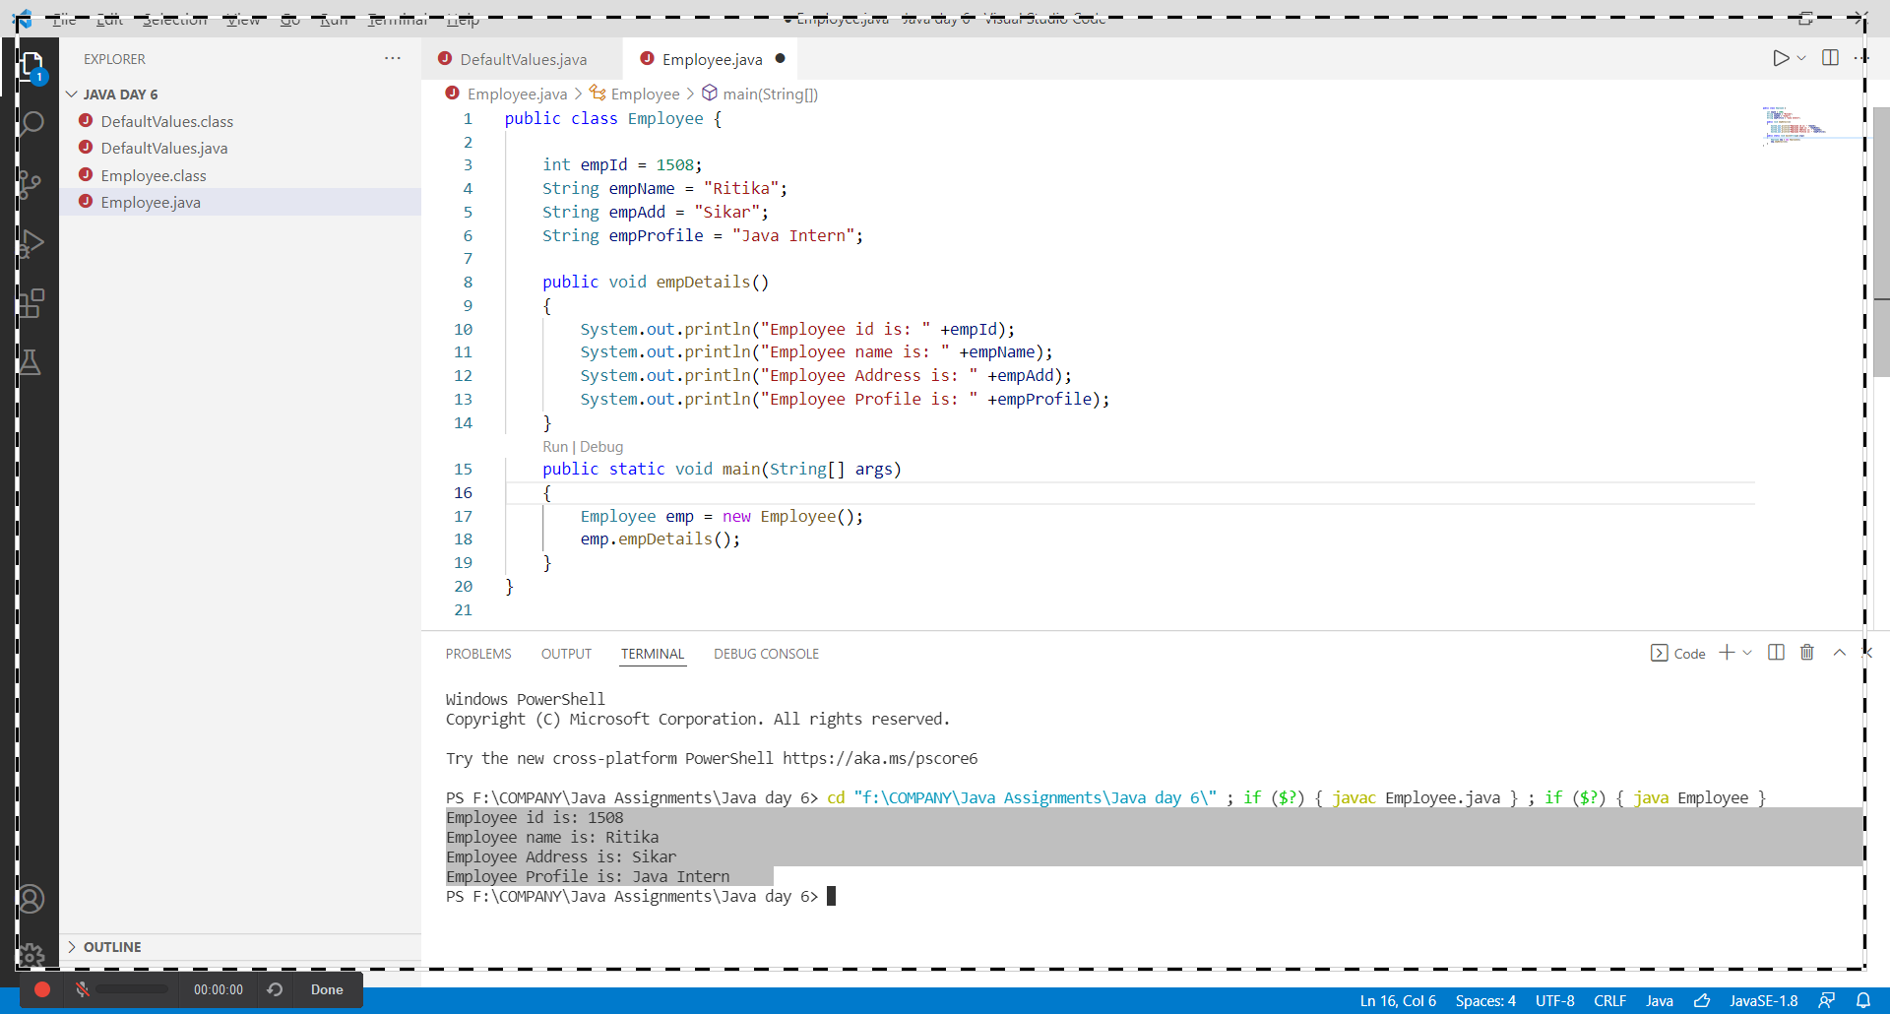

1. Create Student class with global variables and related methods with constructor and without constructor

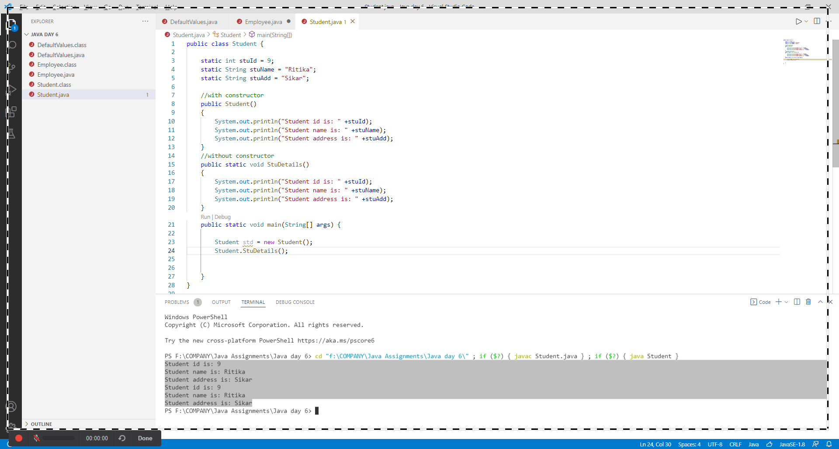

1. observe the difference between methods calling and constructor calling.

